CHAPTER 1
INTRODUCTION OF THE REPORT
This internship is intended to strengthen my academic foundation in my respective fields of study by providing practical experience through the application of classroom knowledge to real-world and community-based scenarios. It enabled us to engage in diverse hands-on work experiences that align with my interests.
This internship report is organized into five chapters. Chapter 1 introduces the report. Chapter 2 provides an overview of the organization, including sections such as the organization profile, its mission, vision, core values, and the objectives of the internship. Chapter 3 outlines the learning experiences gained during the internship, offering a detailed account of the tasks performed and the lessons learned throughout the three-month period. Chapter 4 presents a SWOT analysis, highlighting the strengths, weaknesses, opportunities, and threats identified. Finally, Chapter 5 offers recommendations and concludes the report.
At the organization, various departments provide training in multiple programming languages. Among these technologies, I was particularly interested in studying Java, C#, .Net Framework, Microsoft Access, Oracle, MongoDB and MySQL. I have documented my best efforts in this report, and I kindly request your understanding for any shortcomings.

CHAPTER 2
OVERVIEW OF THE ORGANIZATION
The organization is structured into four main technical and administrative teams to ensure smooth operations and the effective delivery of services. These teams include:
R N D
- The HR & Administrative Team: Responsible for talent recruitment, employee welfare, project tracking, and enforcing internal corporate policies.
- Laravel Team: Focuses on designing, developing, and customizing modern web applications and enterprise platforms using the Laravel framework.
- Mobile Team: Specialized in mobile application design and development, providing consultation and customized mobile solutions for clients.
- Odoo Team: Handles Enterprise Resource Planning (ERP) consulting, customization, and implementation using the Odoo platform.
- .NET Team: Dedicated to building scalable enterprise solutions, backend services, and software platforms utilizing Microsoft .NET technologies.
These technical divisions (Laravel, Mobile, Odoo, and .NET) collectively function as the Research and Development (R&D) powerhouse of the company. Engineers across these teams actively research modern frameworks, design system architectures, and manage the end-to-end software development lifecycle to deliver tailored business management platforms. Each team operates collaboratively to drive digital transformation and support the organization’s strategic goals.
2.1 Company Profile
The Enterprise Solution Software & Service Co., Ltd serves as a cornerstone of the organization's technological infrastructure. Its primary goal is to become a leading technology company in Myanmar by delivering innovative IT services to meet customer needs. The department focuses on delivering cutting-edge IT solutions, ensuring customer satisfaction, and driving sustainable business growth through technology.

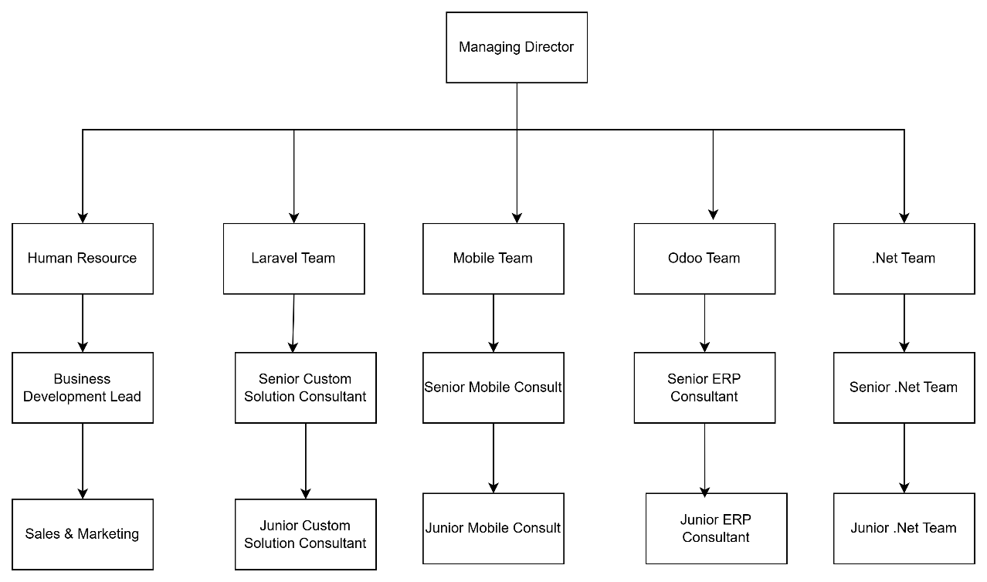
Figure 2.1 Organizational Structure
2.2 Company’s Mission, Vision
Mission
- To revolutionize the way, IT service professional deliver services.
- To provide the innovation solutions to my customer to satisfy their unique business needs.
Vision
- To be the leading technology company in Myanmar.
- To be delivering innovative solutions that help businesses achieve their goals and grow sustainably.
2.3 Internship Objectives
The objectives of the internship are as follows:
- To develop new skills and enhance existing ones.
- To expand my understanding of how academic knowledge applies real-world situations.
- To again confidence, improve decision-making, and strengthen teamwork abilities essential for professional success.
- To improve communication skills, independent learning, and problem-solving skills.
- To explore a specific field of interest and evaluate it as a potential career path.
CHAPTER 3
LEARNING EXPERIENCE DURING INTERNSHIP
I first received guidance from my supervisor to search for a suitable internship opportunity at an IT company. After careful consideration, I decided to apply to Enterprise Solution Software & Service Co., Ltd., which I believed would be highly beneficial for my growth in the technology sector. I contacted the company to inquire about internship opportunities and submitted my CV along with application form. About two weeks later, I was invited for an interview, and by the fourth week, I was accepted to begin my internship.
I had another discussion with my supervisor and carried out all necessary preparations. During the internship, I had the opportunity to explore the programming languages and frameworks I would be using in more depth. I was confident that this experience would provide valuable and diverse learning opportunities.
I interned at Enterprise Solution Software & Service Co., Ltd for a total of three months. In consultation with my supervisor, I finalized my project title, Leave Management System, and defined its functional scope. I independently studied project features, documentation, and sample code from online resources.
As the project was assigned to me individually, I faced several challenges, including coding errors, unfamiliar methods. And it takes us time to understand the C#, .Net Framework. The project officially started on May 1, 2026, and was completed by July 31, 2026. At times, I worked overtime to stay on schedule and overcome technical obstacles.
Throughout the internship, I gained valuable experience in areas such as time management, coding, cooperation with other team members, logical thinking, and requirements gathering from various kind of customer. I also deepened my knowledge of technologies such as Visual Basic Application, C# , .Net Framework , Microsoft Access ,Oracle ,Mongo DB, MySQL, PHP, and Laravel Framework. Whenever I encountered difficulties during my study, I consulted my supervisor and senior team members, and conducted research through official documentation and online tutorials.

3.1 Description of Duties and Lessons I Learned
First of all, I learned the process flow of internship projects. I studied HTML5, CSS, JavaScript, Bootstrap 5, as well as database design principles using ER diagrams. In addition, I gained practical knowledge of backend development concepts, C#, .NET Framework, and system testing methodologies. Throughout the development process, most technical bugs and errors were resolved through independent online research and official developer documentation. As a result, I gained a lot of valuable hands-on experience during this period.

3.1.1 Activities of First Month (May)
Table 3.1 Activities of First Month (May)
Date | Task (Details)
1.5.2026 | Orientation, workplace onboarding, reviewing company IT tools (Microsoft Access / SQL Server), and setting up local development tools (VS Code, Git, XAMPP environment, Composer) for the assigned Laravel Leave Management project.
4.5.2026 | Configured MySQL server settings, verified PHP extensions, and designed the initial ER diagram for Leave Management System (Users, Staff, Departments, Leave Types tables).
5.5.2026 | Implemented User Authentication and Role-based Login (Admin, Staff, Department Head).
6.5.2026 | Created Laravel Database Migrations for users, staff`, and departments database tables.
7.5.2026 | Built “Department Management” CRUD modules (Add, Edit, Delete departments).
8.5.2026 | Built “Staff Management” modules (Add staff records, Update info, Assign to departments).
11.5.2026 | Designed UI forms for Staff and Department administration using HTML5 and Bootstrap 5.
12.5.2026 | Implemented Delete/Deactivate staff records logic with soft deletes in MySQL.
13.5.2026 | Configured “Leave Type Management” database structures and Eloquent Models.
14.5.2026 | Added default Leave Types (Casual, Medical, Annual, Maternity, Paternity, Emergency, Study, Duty Leave).
15.5.2026 | Configured “Leave Balance Allocation” rules (Annual leave quota setup per staff member).
18.5.2026 | Developed frontend interfaces for Staff profiles and Department listings.
19.5.2026 | Implemented server-side input validation routines for Staff registration and profile updates.
20.5.2026 | Created Database Seeders to insert dummy staff and departmental test records.
21.5.2026 | Configured Git repository branches and committed initial core setup code.
22.5.2026 | Designed the “Leave Application” submission form schema and frontend layout.
25.5.2026 | Implemented file upload feature for attaching supporting documents (Medical certificates, etc.).
26.5.2026 | Added backend date calculation logic to calculate requested leave duration in days.
27.5.2026 | Integrated form validation to prevent leave submission if remaining balance is insufficient.
28.5.2026 | Tested Leave Application submission workflows under the Staff user role.
29.5.2026 | Refactored form layout and Blade component templates for mobile responsiveness.

3.1.2 Activities of Second Month (June)
Table 3.2 Activities of Second Month (June)
Date | Task (Details)
1.6. 2026 | Fixed date-picker boundary bugs for leave start and end dates.
2.6. 2026 | Conducted progress review for First Month deliverables with supervisor.
3.6. 2026 | Initiated work on the “Leave Approval Workflow” for Department Heads and Admins.
4.6. 2026 | Created views to display Pending, Approved, and Rejected leave requests.
5.6. 2026 | Implemented Approve and Reject action endpoints with compulsory Approval Remarks.
8.6. 2026 | Built automatic “Leave Balance Management” update triggers upon request approval.
9.6. 2026 | Developed the Staff "Track Leave Request Status" UI and real-time status badges.
10.6. 2026 | Implemented personal "Leave History" table view with filtering options for Staff users.
11.6. 2026 | Added role authorization middleware to restrict access based on user role permissions.
12.6. 2026 | Fixed database foreign key constraints between `leave_applications` and `leave_types`.
15.6. 2026 | Developed the “Department Head” review dashboard and departmental queue views.
16.6. 2026 | Resolved edge cases where overlapping leave date ranges were submitted by staff.
17.6. 2026 | Built initial “Dashboard Analytics” layout showing Total Staff count.
18.6. 2026 | Added metrics cards for Total Leave Requests, Approved, Rejected, and Pending counters.
19.6.2026 | Optimized MySQL queries for Leave Balance calculations using Eloquent query caching.
22.6. 2026 | Implemented email/system alert notification triggers for pending leave reviews.
23.6.2026 | Tested cross-role workflows (Staff submit -> Dept Head approve -> Balance update).
24.6.2026 | Reviewed system code security against CSRF, SQL Injection, and Unauthorized access.
25.6. 2026 | Refactored Leave Application controller methods for modular readability.
26.6. 2026 | Conducted responsive UI adjustments for mobile device screen resolutions.
29.6. 2026 | Conducted mid-term progress review with senior technical developers.
30.6. 2026 | Logged system bug tickets and resolved UI rendering defects in GitLab.

3.1.3 Activities of Third Month (July)
Table 3.3 Activities of Third Month (July)
Date | Task (Details)
1.7. 2026 | Performed integration testing across Department Head and Administrator workflows.
2.7. 2026 | Updated project documentation and database schema ER diagrams.
3.7. 2026 | Developed the “Report Generation” module for Staff Leave History reports.
6.7. 2026 | Implemented Department-wise Leave Report generation with date range filtering.
7.7. 2026 | Created Monthly Leave Statistics queries and aggregated summary charts.
8.7. 2026 | Built Annual Leave Summary export features (Excel / PDF format export).
9.7. 2026 | Verified precision of remaining leave balance calculations across all leave types.
10.7. 2026 | Adjusted dashboard UI widgets for displaying active leave statistics.
13.7. 2026 | Conducted User Acceptance Testing (UAT) with internal HR team members.
14.7. 2026 | Gathered UAT feedback and refined Approval Remarks input UI.
15.7. 2026 | Conducted stress testing on report queries with large dataset volumes.
16.7. 2026 | Cleaned up temporary test data and executed fresh SQL database seeders.
17.7. 2026 | Demonstrated the complete Leave Management System walkthrough to supervisor.
20.7. 2026 | Prepared system user manual and deployment documentation.
21.7. 2026 | Pushed final code version to company GitLab repository.
22.7. 2026 | Conducted code review with senior developers and system architects.
23.7. 2026 | Exported final MySQL database SQL dump files.
24.7. 2026 | Added code documentation comments to controllers and models.
27.7. 2026 | Attended final evaluation meeting with management.
28.7. 2026 | Obtained internship completion sign-off from HR.
29.7. 2026 | Transferred system source code to internal repository.
30.7.2026 | Prepared the PowerPoint presentation for project defense.
31.7.2026 | Completed task handover documentation and finalized project book.

CHAPTER 4
ANALYSES
My internship served as a gateway into the real-world work environment, offering us a firsthand look at how businesses operate. It allowed us to apply my academic knowledge into action while adapting to a professional setting. Collaborating with fellow interns and team members provided us with valuable perspectives and practical learning opportunities. The entire experience enriched my understanding and made a lasting impact on my professional development. During this period, I engaged in web design projects, strengthened my command of the English language, and improved my technical skills in SQL and the Laravel framework using advanced PHP.
These activities not only enhanced my technical abilities but also helped build my confidence, communication, time management, and ability to set and pursue goals. I witnessed how classroom theories translate into workplace applications, which helped us bridge the gap between school and real-world challenges. With the guidance of my mentors, I learned to handle complex tasks and sharpened my analytical and problem-solving abilities. The combination of a supportive atmosphere and challenging assignments pushed us to grow, overcome my limits, and aim for excellence.
4.1 Strengths
This internship provided me with an invaluable opportunity to apply the knowledge I acquired at university in a real-world enterprise setting. However, I soon came to understand that academic knowledge alone was not enough; I also needed to cultivate crucial workplace competencies such as collaboration, decision-making, problem-solving, planning, effective communication, organization, and handling information efficiently. At university, programming languages were mostly covered in a theoretical context. While I understood the core concepts and logic, I still faced practical obstacles during hands-on tasks in the internship. On the bright side, these challenges helped us enhance my ability to overcome difficulties and find effective solutions.
Each time I was assigned a project module or task, I aimed to deliver high-quality results within the given timeframe. Despite my dedication and hard work, things didn’t always proceed as planned. One of the most important lessons I learned was how to manage time wisely, even under pressure, as staying on schedule reflects personal accountability and professional discipline. Moreover, I strongly believe that the skills, hands-on framework experience, and practical knowledge gained through this internship will boost my confidence when attending job interviews in the IT industry.
4.2 Weaknesses
During my internship in the software team of the company, I encountered several challenges. Although the team members were technically skilled, they were frequently busy with project deadlines, which limited opportunities for me to ask detailed questions or receive timely feedback. Communication within the team was mostly done through technical terms, which was initially difficult for me to fully understand as a junior intern. Furthermore, my internship period coincided with the rainy season, during which weather-related health issues affected both interns and staff, occasionally delaying internal coordination.
Additionally, the city experienced frequent power outages, which disrupted my development workflow, especially during code compilation and system testing. Another weakness I observed was the limited documentation for some of the internal tools or modules, which made it harder for us to learn or contribute independently. As a result of all these factors, I experienced some delays in my project development and faced difficulties in maintaining continuous progress.
4.3 Opportunities
Throughout my three-month internship, I was exposed to various valuable opportunities:
- I developed essential competencies in system architecture design, database modeling, and structured project planning.
- Tackling real-world challenges sharpened my problem-solving abilities and helped us approach issues with more effective solutions.
- I gained practical insight into how programming languages function throughout their lifecycle in real-world applications.
- This internship experience helped us reflect on my career aspirations and guided us in making more informed decisions about my future profession.

4.4 Threats
One of my major technical concerns during the internship was the risk of not completing the project on time due to my laptop’s poor performance. Additionally, I felt nervous about presenting my system to a live audience, fearing potential discomfort or performance issues during the demonstration.

CHAPTER 5
RECOMMENDATIONS AND CONCLUSION
The internship program represents a significant opportunity for students to bridge the gap between academic learning and real-world application. While studying programming languages at university, it was often unclear how these skills would be applied in a professional software development setting. Through my internship at Enterprise Solution Software & Service Co., Ltd., where I developed a Leave Management System, I was able to see firsthand how to implement what I had learned in a real-world job context. Fortunately, this experience not only reinforced my fundamental programming knowledge but also provided invaluable practical insights into enterprise software development.
My university predominantly focuses on theoretical instruction across all courses, including programming. However, practical teaching and laboratory courses have proven to be more effective than purely theoretical ones. Therefore, it is recommended that the university enhances its support for students in securing internship placements aligned with their academic programs. This could be achieved through providing strong recommendations and facilitating connections with industry partners. Continuing the internship program is crucial as it prepares students for their future careers by allowing them to practice and apply the theoretical knowledge gained in the classroom.
In conclusion, my internship experience at Enterprise Solution Software & Service Co., Ltd. has been immensely beneficial. Developing the Leave Management System allowed me to apply the theoretical knowledge acquired at university to practical system design, database administration, and assignments. This hands-on experience has been instructive and invaluable, significantly enhancing my understanding and skills. The opportunity to learn and grow in a professional environment was a pivotal part of my education. I am deeply grateful for the experience and the chance to gain practical insights that will undoubtedly aid us in my future career endeavors.

REFERENCES
- https://www.esmyanmar.com.mm
- https://www.pinterest.com
- https://dhammadownload.com
- https://www.w3schools.com

